# How to Incorporate Git with Visual Studio Guide

**Company:** MacAulay-Brown Inc. an Alion Science Company

**By:** Jonathan Kinnard

**Date:** 4/6/2020

*This guide assumes you already have git and Visual Studio installed in your computer.*

Go to your git repo in a web browser and click the green button to clone or download your repo. Choose to clone it, and copy the link by selecting the circled button:

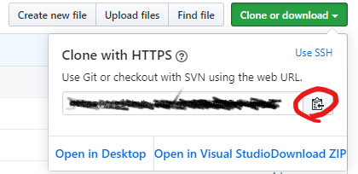

Open visual studio and select clone or checkout code:

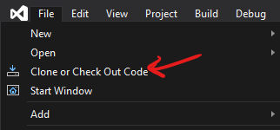

Follow the prompts to make a local repo. Next, install the git extension for VS by typing “git” into the search bar and choosing “Install Git for Windows”:

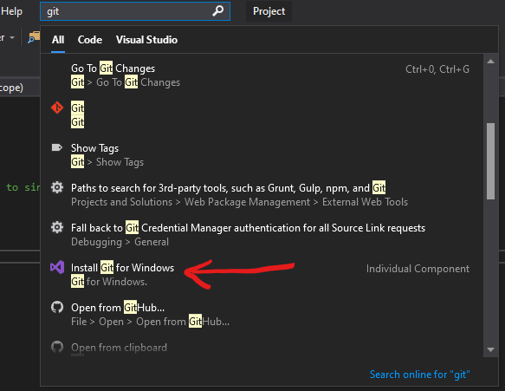

Follow the prompts. Next, login to your git by choosing the link in the Teams Explorer window of VS. In the following picture, the arrow is pointing to where the link would be if you were not logged in.

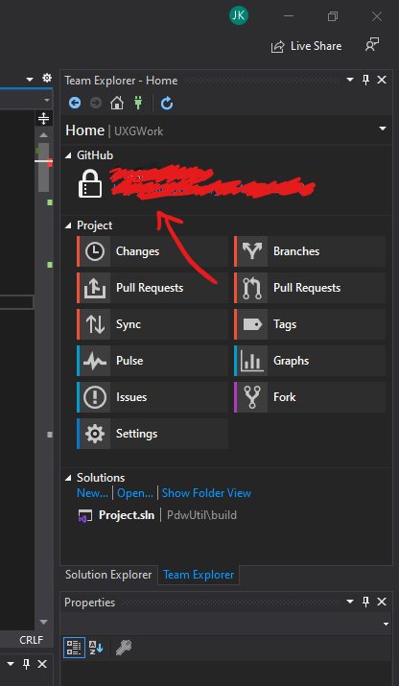

Make a change to one of the files (By clicking on Solution explorer and typing a space for example on one of the files) then return to the Team Explorer and click “Changes”.

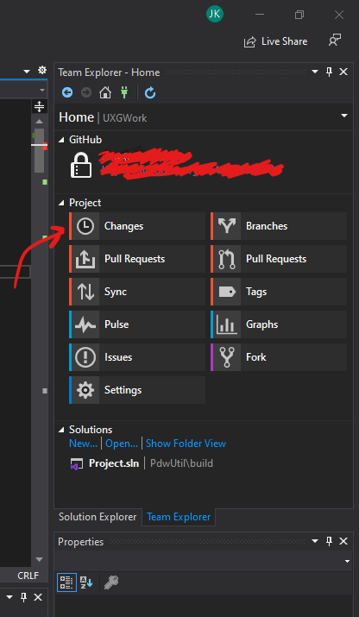

Enter a commit message and click the arrow to the right of the commit button and say “Commit and push”.

If you run into this error:



You need only add a few files by going to settings->repository settings. The arrows in the following picture point to where the “add” options would be.

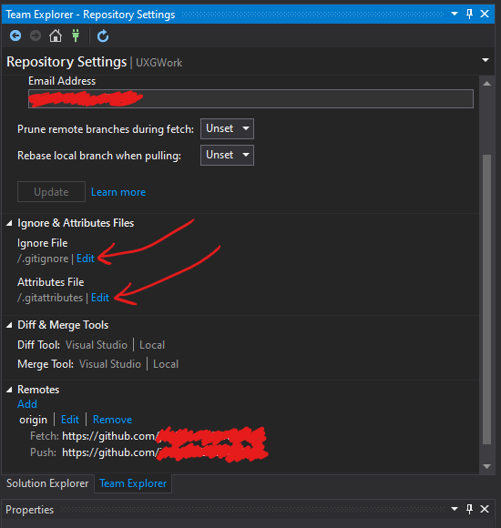

Finally, check your repo in a web browser to ensure your push worked.

Final Notes:

* You may need to rebuild the project within the repo with a new build file using cmake.
* Depending on your setup, that “master” option at the bottom right of VS may give you the option to “push” but know you are only pushing to your local repo (depending on your setup) and not your remote git. To be 100% sure, use the “changes” option in the “teams” window.

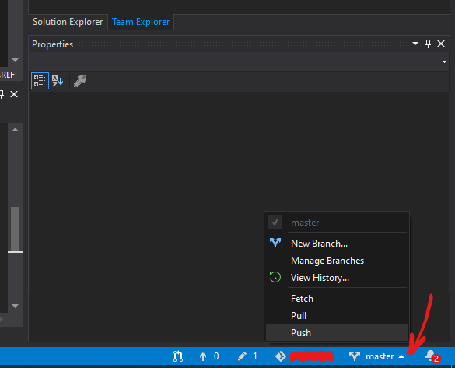

* If you encounter more problems and want to “google” your way through it, note that a lot of articles are about incorporating git with Visual Studio Code and not Visual Studio. Two very different products.